Lecture № 1.

Lecture 1. Introduction. A brief historical overview of nanotechnology. Basic fundamental questions of nanoscience.

The discipline “Colloid chemistry and technology of nanodisperse systems” represents the interdisciplinary course including fundamentals of Colloid Science and Nanochemistry. This course describes nanodisperse systems and their properties, methods of nanomaterial preparation based on knowledge of previous courses devoted to Colloid Chemistry.
The Colloid Chemistry and Nanochemistry have common objects of research – nanoparticles and nanosystems. A new area of science referred to as the Chemistry and Technology of Nanosystems, also known as Nanochemistry, has emerged.
Colloid Chemistry studies the substances in the dispersed state or disperse systems. The systems of interest in colloid chemistry include coarse disperse systems (with sizes of 1 μm or larger and with surface area less than 1 m²/g) and fine disperse systems. Fine disperse systems are ultramicroheterogenious colloidal systems with fine particles down to 1 nm in diameter and with surface areas reaching 1000 m²/g (nanosystems).
Nanochemistry studies the nanoparticles and nanosystems. From the point of Colloid Science view nanoparticles and nanosystems relate to the fine disperse systems. Today the new field of Colloid Science has emerged which called as Colloid chemistry of nanoparticles and nanodisperse systems.
Nanoparticles are characterized by at least one dimension in the nanometer range and they are objects of nanochemistry research.
A nanometer (nm) is one billionth of a meter, or 10^{–9} m. One nanometer is approximately the length equivalent to 10 hydrogen or 5 silicon atoms aligned in a line.
Nanoscience is a relatively new area of knowledges which studies fundamental properties of substances (nanomaterials, nanosystems) in nanometer scale. Nanoparticle and nanosystems possess with outstanding electrical, optical, magnetic and mechanical properties are rapidly being developed for use in information technology, bioengineering, medicine, industry and energy and environmental applications due to nanotechnologies.
The term “nanotechnology” was invented at first time by Professor Norio Taniguchi at the University of Tokyo in 1974 for estimation of accuracy of processed surfaces.
The original definition of N. Taniguchi, translated into English:

“Nanotechnology is the production technology to get the extra high accuracy and ultra fine dimensions, i.e. the preciseness and fineness on the order of 1 nm (nanometer), 10-9 meter in length.”
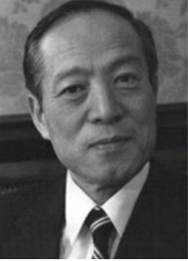

Figure 1. – Norio Taniguchi (1912 –1999) was a professor of Tokyo University of Science. He coined the term nanotechnology in 1974.

After invention of scanning tunneling microscope in 1981 the term “nanotechnology” found a new development. Because it has given the opportunity to assemble artificially the nanomaterials and nanodevices from single atoms and molecules.
Nanotechnology studies the manipulating matter at the atomic and molecular scale. Nanotechnology literally means any technology on a nanoscale that has applications in the real world. Nanotechnology encompasses the production and application of physical, chemical, and biological systems at scales ranging from individual atoms or molecules to submicron dimensions, as well as the integration of the resulting nanostructures into larger systems.
Nanotechnology is the art and science of manipulating matter at the nanoscale (down to 1/100,000 the width of a human hair – to imagine brightly at the philistine level) to create new and unique materials and products with enormous potential to change society.
The one of contemporary definitions of nanotechnology according to NASA’s definition:

“Nanotechnology is the creation of functional materials, devices and systems through control of matter on the nanometer length scale (1-100 nanometers), and exploitation of novel phenomena and properties (physical, chemical, biological, mechanical, electrical...) at that length scale.”

Although nanotechnology is a rather new area of study, nanomaterials are known to be used for centuries. For example, the Chinese used gold nanoparticles as an inorganic dye to impart red color for their ceramic porcelains more than thousand years ago. Roman glass artifacts contained metal nanoparticles, which provided beautiful colours. In medivial times, nanoparticles were used for decoration of cathedral windows (Fig.1).

 | 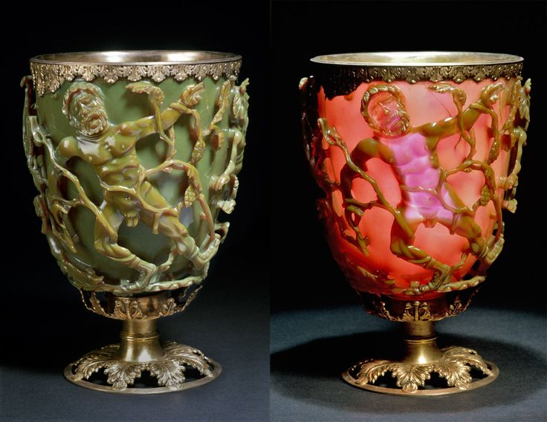
- b)
Figure 2. – Examples of ancient nanotechnologies a) decoration of Canterbury cathedral, window (Great Britain)
- extraordinary cup was probably made in Rome in the 4th century AD (British Museum).

Michael Faraday was the first who conducted the systematic studies on the properties of metal colloids, in particular, gold (Fig.3). In 1857, during his lecture at the Royal Society of London, Faraday presented ‘gold reduced in exceedingly fine particles, which becoming diffused, produce a ruby-red fluid … the various preparations of gold, whether ruby, green, violet or blue … consist of that substance in a metallic divided state’.

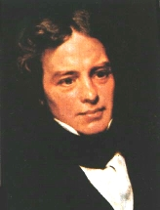 | 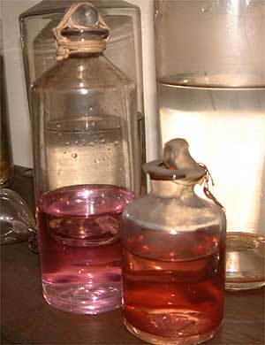
- b)

Figure 3. – a) Michael Faraday, (1791-1867); b) Gold sol, prepared by Faraday
Table 2 summarizes the outline of the historical background relating to nanoparticles (nanotechnology).

Table 2. Chronological table of nanotechnology.

Year | Description | Country/people, scientists
1200–1300 BC | Discovery of soluble gold | Egypt and China
290–325 AD | Lycurgus cup | Alexandria or Rome
1618 | First book on colloidal gold | F. Antonii
1676 | Book published on drinkable gold that contains metallic gold in neutral media | J. von Lowenstern-Kunckel (Germany)
1718 | Publication of a complete treatise on colloidal gold | Hans Heinrich Helcher
1857 | Synthesis of colloidal gold | M. Faraday (The Royal Institution of Great Britain)
1902 | Surface plasmon resonance (SPR) | R. W. Wood (Johns Hopkins University, USA)
1908 | Scattering and absorption of electromagnetic fields by a nanosphere | G. Mie (University of Gottingen, Germany)
1931 | Transmission electron microscope  (TEM ) | M. Knoll and E. Ruska (Technical University of Berlin, Germany)
1937 | Scanning electron microscope (SEM ) | M. von Ardenne  (Forschungs laboratorium fur Elektronenphysik, Germany)
1959 | Feynman’s Lecture on “There’ s  Plenty of Room at the Bottom” | R. P. Feynman (California Institute of Technology, Pasadena, CA,USA)
1960 | Microelectromechanical systems (MEMS ) | I. Igarashi (Toyota Central R&D Labs, Japan)
1960 | Successful oscillation of a laser | T. H. Maiman (Hughes Research Laboratories, USA)
1962 | The Kubo effect | R. Kubo (University of Tokyo, Japan)
1965 | Moore’ s Law | G. Moore (Fairchild Semiconductor Inc., USA)
1969 | The Honda–Fujishima effect | A. Fujishima and K. Honda (University  of Tokyo, Japan)
1972 | Amorphous heterostructure  photodiode created with bottom-up process | E. Maruyama (Hitachi Co. Ltd., Japan)
1974 | Concept of nanotechnology proposed | N. Taniguchi (Tokyo University of Science, Japan)
1976 | Carbon nanofiber | M. Endo (Shinshu University, Japan)
1976 | Amorphous silicon solar cells | D. E. Carlson and C. R. Wronski (RCA, USA)
1980 | Quantum hall effect | Nobel Prize) K. von Klitzing (University of Wzburg,  Germany)
1981 | Scanning tunneling microscope  (STM ) (Nobel Prize) | G. Binnig and H. Rohrer (IBM Zurich Research Lab., Switzerland)
1986 | Atomic force microscope (AFM ) | G. Binnig (IBM Zurich Research Lab., Switzerland)
1986 | Three-dimensional space  manipulation of atoms demonstrated (Nobel Prize) | S. Chu (Bell Lab., USA)
1986 | “Vehicles of creation: the arrival of the nanotechnological era” | E.Drexler, Massachusetts Institute of Technology, USA
1987 | Gold nanoparticle catalysis | M. Haruta (Industrial Research Institute  of Osaka, Japan)
1990 | Atoms controlled with scanning  tunneling microscope (STM) | D. M. Eigler (IBM, USA)
1991 | Carbon nanotubes discovered | S. Iijima (NEC Co., Japan)
1992 | Japan’s National Project on Ultimate Manipulation of Atoms and Molecules  begins | Japan
1995 | Nano-imprinting | S. Y. Chou (University of Minnesota,  USA)
1996 | Nano sheets | T. Sasaki (National Institute for Research  in Inorganic Materials, Japan)
2001 | National Nanotechnology Initiative (NNI) | USA
2003 | 21st Century Nanotechnology Research and Development Act | USA
2005 | Nanosciences and Nanotechnologies: An action plan | Europe

As it seen in Table 2 in 1959 Richard Feynman delivered the lecture on “There’ s Plenty of Room at the Bottom” (Fig.4). For the first time, he emphasized importance of smallsized products with the use of atoms as building particles. Therefore, this lecture is referred to as the origin of the nanotechnological paradigm.



Figure 4. – Richard Feynman (1918-1988), American theoretical physicist known for his work in the path integral formulation of quantum mechanics, the theory of quantum electrodynamics, and the physics of the superfluidity of supercooled liquid helium, as well as in particle physics for which he proposed the parton model. He is regarded as a founder of nanotechnology for his speech on top-down nanotechnology called “There's Plenty of Room at the Bottom”.

Some ideas of Richard Feynman were developed by E.Drexler (Massachusetts Institute of Technology, USA ) in his book “Vehicles of creation: the arrival of the nanotechnological era” published in 1986 (Fig.5). E.Drexler introduced imagination about molecular robotics based on biological models. It was mentioned on strategy of “bottom-up” in contrary to “top-down” method.
In the second half of 1980s to the early 1990s a number of researches and publications on nanotechnology increases extremely, which created a significant influence on further development of nanotechnologies over the world.
After 2000s different countries initiated their National programs (USA, Europe countries, Japan, China, South Korea, Russia) on development of nanotechnologies for their introduction to economy, industry, medicine, national security and other fields.


Figure 5 – Eric Drexler, is an American engineer best known for popularizing the potential of molecular nanotechnology

More and more attention is given to nanotechnology development in Kazakhstan within the framework of state scientific programs. For example, in Kazakh National University the National Nanotechnological Laboratory was opened in 2008 where scientists can carry out their investigations, prepare the qualified specialists, develop “breakthrough” projects in this field.

Here are some definitions used in the field of nanotechnology:
- Nanochemistry studies the synthesis and features of physical and chemical properties of nanoparticles and nanosystems.
- Nanoparticle is an aggregate of atoms (molecules) bonded together with a radius between 1 and 100 nm. It typically consists of 10–10⁵ atoms. Nanoparticles form dispersed phase of disperse system and the interface with the surrounding dispersion medium.
- Nanostructures are nanoparticle aggregation at presence of connections between them and maintaining the peculiarities of nanoparticles.
- Nanocomposites are number of nanoparticles characterizing by a significant interaction between them.
- Nanosystems сonsist of nanoparticles and their surrounding medium (gas, liquid, solid body).

Revision questions:

- What are objects of study of Colloid Chemistry and Nanochemistry?
- What are fine disperse systems?
- Why one can say that Colloid Chemistry and Nanochemistry have common objects of research?
- What are nanoparticles?
- What does mean prefix “nano”?
- Who was the first invented the nanotechnology term?
- Give the definition of nanotechnology.
- Describe the early background of nanotechnology.
- Describe the history of nanotechnology.
- Why R.Feynman is regarded as one of founder of nanoscience?
- How you can characterize the state of nanotechnology in Kazakhstan?

